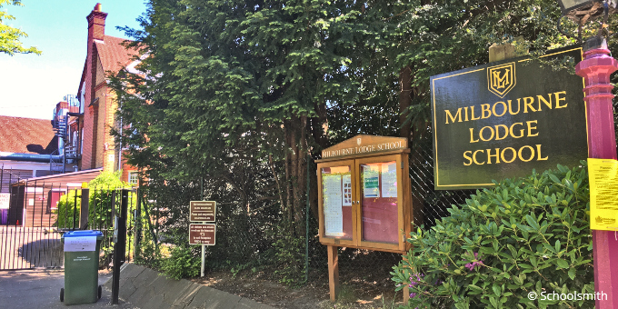

**Job Profile: School IT Technician  
*+ Projects & roaming support role***

|  |  |
| --- | --- |
| Function/Department | School IT Technician – on site |
| Location | Glenesk School, Milbourne Lodge Prep, Downsend Schools  + Pod 2 schools as and when required. |
| Reports to | UK Pod 2 IT Manager |
| Position Type | Permanent |
| Status | Full Time |
| Salary range | Based on industry benchmarks – more details upon enquiry. |

***We believe having a diverse workforce makes us better, smarter, and happier and so welcome applicants from all backgrounds, genders, and races. We have an unwavering commitment to being fair and equitable in our recruitment process.***

**About Us**

Established in 2004, Cognita is an extraordinary family of diverse yet connected schools, spanning fifteen countries across the globe. We share one common purpose: to create an inspiring world of education that builds self-belief and empowers individuals to succeed. With over 100 schools in Europe, Latin America, North America, Middle East and Asia, we employ 15,000+ teaching and support staff who are devoted to the care and education of more than 80,000 students. We are growing every year.

UK Pod 2 Schools

**What makes a “Cognita Person”?**

We look to employ smart, committed, and personable colleagues who we can trust, colleagues who we know will be there for each other, no matter what challenges we may face. We truly believe that building self-confidence and empowering individuals to succeed (students and colleagues) is a worthy goal, and a vision that binds us together. Each of us in the team contribute to delivering an outstanding holistic education to our students.

**Purpose of this role.**

* **This is a unique role within our team and is ideally suited to someone who likes a more dynamic role, a role in which you get to visit different places, work with lots of colleagues and have more involvement with our projects teams.**
* **Whilst you will be based at the Glenesk, Milbourne and Downsend sites, working alongside another technician, you will sometimes travel to our other Pod 2 school sites (our schools south of London priority) for a day or for short periods (2 or 3 days) to help implementing projects; working alongside, and covering for another technician (e.g. rolling out new devices to staff, rolling out iPads to our younger students).**
* **As you grow into the role you will also become a technical mentor to new IT technicians. Working with them in their initial days in the role, introducing them to our procedures and systems – making sure they get the best possible start and hit the ground running.**
* **In the rare case that a school technician is off sick for a week or two, you would visit the affected school for a few days to ensure they continue to get the support that they need.**
* **When overnight stays are required, hotels will be booked for you, and you can claim for evening meals (lunch will be provided onsite at our schools).**
* **This is a great opportunity to see the country and become a vital member of our support team, helping schools to deliver great outcomes for our students and staff.**
* **This role requires the ownership of a reliable car and a full, clean UK driving licence.**

**About you**

|  |  |
| --- | --- |
| **Interpersonal skills** | * Terrific customer service and communication skills, both written & verbal. * Excellent interpersonal skills and the ability to interact effectively & professionally with people at all levels of an organization. * Great communication skills, with the ability to explain technical matters to non-technical people in a language that they can understand. * A team player, who is happy to ask questions and give advice. * The ability to show empathy to others and to remain calm and professional with colleagues and students. * An active listener who is comfortable with offering their opinions in a constructive manner. |
| **Approach to work** | * Self-motivated and pro-active with effective time management and the ability to work unsupervised. * Must be able to use initiative and work under pressure, consistently employing a customer centric approach to resolving all IT issues. * Demonstrable methodical problem solving, excellent analytical skills and creative thinking. * Able to demonstrate good judgement and decision-making skills in resolving issues in challenging situations, knowing when to sign post, escalate and resolve issues. * Comfortable in establishing new processes and procedures as well as following those already in place. * Always looking for ways to improve the service delivered. * Happy to maintain up to date inventories. |
| **Technical skills** | * Windows Server 2012/2016/2019/22 * Windows 10 / Windows 11 * Active Directory support * Office365 * Microsoft Office: Desktop versions * LAN & WAN technologies and protocols, including VLAN, wireless, DNS and DHCP. * MIS (experience will be useful but not essential) * AV and interactive boards and screens * Shared printing solutions * Experience with Azure AD and some knowledge of Intune * Desktop/Server Hardware support and troubleshooting * Apple device management and support (mainly iPads) |
| **Work Experience** | * Experience of working in an onsite environment (mainly 2nd line, with some 3rd line support role). * Experience of working in a customer facing environment. * Experience of working in the education or similar sector is preferable, but not essential. |
| **Safeguarding responsibilities** | * To comply with safeguarding policies, procedures, and codes of conduct. * To demonstrate a personal commitment to safeguarding and student/colleague wellbeing. * To ensure that any safeguarding concerns or incidents are reported appropriately in line with policy. * To engage in safeguarding training whenever required. |

|  |  |
| --- | --- |
| **Renumeration** | * Competitive salary, benchmarked against industry standards. * Company laptop and mobile phone. * Contributory pension scheme. * Private healthcare. * Life assurance. * “My Staff Shop” account, with some great discounts and rewards. * School fee discount. * Professional development. * Fuel payments related to work mileage (£0.45 per mile for the first 10000 miles. £0.25 per mile thereafter). * 25 days holiday + 1 day for your birthday (discretionary extra days off over the Christmas period are frequently allocated). |

**What sets this role apart from similar roles with other employers?**

* Make a difference to peoples’ lives and see the impact that your work has on the quality of education and experiences that our students and staff receive.
* Working in an environment with plenty of variety in terms of exposure to new technologies and new support requests – this is not a mundane workplace with the same experience every day.
* Wider support team of friendly, responsive technicians available on Teams for questions and help.
* High quality, uniform hardware (standard across all sites).
* A rolling replacement scheme, meaning that you will never be working with outdated tech, and you will not spend time keeping old devices working “past their sell by dates”.
* Higher level server, security and network functions are managed by inhouse 3rd line support – you will not be alone when dealing with major incidents or complex issues.
* Close, supportive managerial relationships within focused regional teams – you will be treated as an individual, not just a number within an organisation.
* Collaborative culture in which staff are encouraged to be independent and share honest feedback with their managers and peers.
* Opportunity to work with project teams and upskill in focused areas.
* Quality free lunches in school.
* “Sales” do not form any part of this role and there will never be an expectation for you to sell or focus on sales targets.